**MIN FILTER**

* To find the darkest points in an image.
* Finds the minimum value in the area encompassed by the filter.
* Reduces the salt noise as a result of the min operation.
* The 0th percentile filter is min filter.

[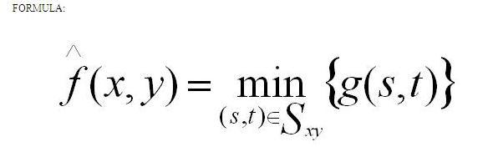](https://2.bp.blogspot.com/-ARJizy386SA/UXV8N0-v59I/AAAAAAAAAz8/2PeSQtEgZ1g/s1600/min_form.JPG)

[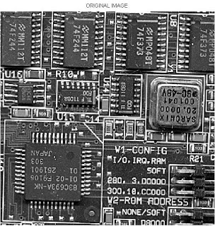](https://3.bp.blogspot.com/-ngraYgBlf6A/UXVw3fEMs9I/AAAAAAAAAzo/FLRDqAbMYgM/s1600/max_input.jpg)

[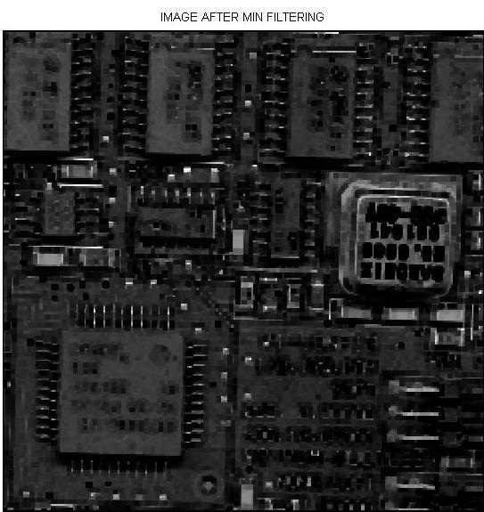](https://1.bp.blogspot.com/-2Fm47HU78MA/UXV8-rdU--I/AAAAAAAAA0E/9WolouxrRKk/s1600/min_filter01.jpg)